**EduConsult-Advisory System**

**Mikhail Hussain Bin Sharifaizal**

**COLLEGE OF COMPUTING AND INFORMATICS**

**UNIVERSITI TENAGA NASIONAL**

**Semester 1 2024/2025**

EduConsult-Advisory System

by

Mikhail Hussain Bin Sharifaizal

Project Supervisor: Ts. Eddren Law Yi Feng

PROJECT REPORT SUBMITTED IN PARTIAL FULFILLMENT OF THE

THE REQUIREMENTS FOR THE DIPLOMA IN COMPUTER SCIENCE

UNIVERSITI TENAGA NASIONAL

Semester 1 2024/2025

APPROVAL PAGE

**TITLE:** EduConsult-Advisory System

**AUTHOR:** Mikhail Hussain Bin Sharifaizal

The undersigned certify that the above candidate has fulfilled the condition of the Final Year Project in partial fulfilment for the Diploma in Computer Science.

**SUPERVISOR:**

Signature: _______________________

Name: Supervisor Name

Date: 99th January 2024

**ENDORSED BY:**

Signature: _______________________

Name: Prof. Madya Ts. Dr. Jaspaljeet Singh A.L Ranjit Singh

Dean, College of Computing and Informatics

Date: 99th January 2024

DECLARATION

I hereby declare that this report, submitted to Universiti Tenaga Nasional as a partial fulfilment of the requirements for the Diploma in Computer Science has not been submitted as an exercise for a diploma at any other university. I also certify that the work described here is entirely my own except for excerpts and summaries whose sources are appropriately cited in the references.

This report may be made available within the university library and may be photocopied or loaned to other libraries for the purposes of consultation.



Mikhail Hussain Bin Sharifaizal

Date: 21/1/2025

ABSTRACT

Imagine being a student seeking academic guidance but facing challenges in scheduling appointments or tracking past advising sessions, or an advisor struggling to manage multiple students efficiently due to a lack of an organized system. To address these challenges, I developed the **"EduConsult Advisor-Advisee Management System,"** a user-friendly and efficient solution designed to streamline academic advising. This web-based system allows students to book appointments seamlessly, enabling advisors to set their availability and manage schedules effectively. After each advising session, students can receive a detailed summary of their progress, helping them stay informed and aligned with their academic goals. The system incorporates various components such as a secure database, automated scheduling features, and user-friendly interfaces for both students and advisors. Developed using web technologies like PHP, MySQL, and JavaScript, EduConsult enhances the advising experience by offering a structured, efficient, and accessible platform. This solution not only improves organization and record-keeping but also reduces administrative burdens, making the advising process more productive and goal-oriented.

ACKNOWLEDGEMENT

I would like to express my deepest gratitude to all those who have contributed to the completion of this project. First and foremost, I extend my heartfelt appreciation to my supervisor, Sir Eddren Law Yi Feng. From starting to end of the project development, he always has been there when I don’t understand anything regarding this project and guide me in solving every problem I’m facing throughout this project development. His expertise and insights have been instrumental in shaping the direction and execution of this project.

Secondly, I want to take my family and friends for giving both moral and physical support and help me on solving my problems in my project. Their unwavering support has become a source of strength and motivation

I also would like to thank both of my panel, Madam Zakiah and Madam Noor Saliza, for giving me an idea on improving my project with their honest feedback regarding my project.

Lastly, I extend my appreciation to all individual, institutions and organizations who’s indirect contributes on helping successfully completing my project.

Thank you.

TABLE OF CONTENTS­­­

APPROVAL PAGE i

DECLARATION ii

ABSTRACT iii

ACKNOWLEDGEMENT iv

TABLE OF CONTENTS v

LIST OF TABLES vii

LIST OF FIGURES viii

LIST OF ABBREVIATIONS/NOTATIONS/GLOSSARY OF TERMS ix

CHAPTER 1 INTRODUCTION 1

1.1 Introduction 1

1.2 Problem Statement 1

1.3 Project Objective 1

1.4 Project Scope 2

1.5 Target User 2

1.6 Project Timeline 3

CHAPTER 2 METHODOLOGY 4

2.1 Methodology 4

2.2 Project Development Methodology 5

2.3 Requirement Gathering Techniques 6

2.4 Tools and Technology 7

2.4.1 Programming Language 7

2.4.1.1 PHP 7

2.4.2 Database 7

2.4.3 HTML/CSS 7

2.4.4 MySql 8

2.4.5 Web Development Tools 8

2.4.5.1 Visual Studio Code 8

2.4.5.2 Xampp 8

CHAPTER 3 SYSTEM DESIGN 9

3.1 System Design 9

3.2 Student Flowchart 9

3.2.1 Advisor Flowchart 10

3.2.2 Admin Flowchart 11

3.3 Database Design 12

3.3.1 Admin Table 12

3.3.2 Advisor Table 12

3.3.3 Advisor_Student Table 12

3.3.4 Appointment Table 12

3.3.5 Availability Table 12

3.3.6 Meeting_Progress Table 13

3.3.7 Student Table 13

3.4 Entity Relationship Diagram 13

CHAPTER 4 implementation and testing 14

4.1 Implementation and Testing 14

4.2 MySQL Connection using PHP Scripting / Adobe Setup 17

4.3 Interface Design 18

4.3.1 Admin Interface 19

4.3.2 Advisor Interface 21

4.3.3 Student Interface 24

CHAPTER 5 CONCULSION AND DISCUSSION 27

5.1 Conclusion 27

5.2 Discussion 27

5.3 Future Works 27

REFERENCES 28

APPENDIX A: QUESTIONNAIRE/SURVEY/INTERVIEW 29

APPENDIX B: ORIGINAL DATA 32

**APPENDIX C: RESULT TABLE 41**

LIST OF TABLES

Table 1.6 Project Timeline 6

LIST OF FIGURES

Figure 2.1 Prototype Methodology 4

Figure 4.1 Login Page for EduConsult System 9

LIST OF ABBREVIATIONS/NOTATIONS/GLOSSARY OF TERMS

**OBTS** Online Bus Tracking System

**SDLC** System Development Life Cycle

# INTRODUCTION

## Introduction

## Academic advising is essential for student success, but traditional methods often involve time-consuming processes like manual scheduling and fragmented interactions. The EduConsult system, a web-based Advisor-Advisee Management System, simplifies advising by allowing advisors to set their availability, track student progress, and maintain detailed meeting records. This system enhances the academic experience by fostering seamless collaboration and providing timely support for students.

## Problem Statement

## The academic advising process in many institutions is often inefficient due to reliance on manual methods like emails and text messages. This results in challenges such as inefficient scheduling, fragmented communication, lack of documentation, limited progress tracking, and overburdened advisors. These issues lead to miscommunication, missed follow-ups, and reduced advising effectiveness.

## Project Objective

## To develop a user-friendly system to facilitate efficient communication and appointment scheduling.

## To implement solutions to streamline scheduling and documentation, to ease workloads.

## To establish a structured system to store and access records of meetings, advice, and actions for future use.

## Project Scope

1. **Appointment booking**. The system will allow users to book appointments with advisors based on their availability, ensuring efficient time management and convenience. A waitlist feature may also be implemented, enabling students to join a queue and secure an appointment when a slot becomes available.
2. **Student-Advisor Assignment.** The system will allow administrators to assign students to specific advisors. This feature ensures a structured and organized approach to student support, enabling advisors to provide personalized guidance.
3. **Advisor Availability Management.** The system will enable advisors to set their availability by defining specific time slots during which they are open for appointments. This feature allows advisors to manage their schedules efficiently, ensuring that students can only book meetings during designated times.

## 

## Target User

* Advisor
* Student
* Admin

## Project Timeline

|  |  |  |  |  |  |  |  |  |  |  |  |  |  |  |
| --- | --- | --- | --- | --- | --- | --- | --- | --- | --- | --- | --- | --- | --- | --- |
| **Activity** | **Weeks** | | | | | | | | | | | | | |
| **FYP** | **1** | **2** | **3** | **4** | **5** | **6** | **7** | **8** | **9** | **10** | **11** | **12** | **13** | **14** |
| 1. Project Planning |  |  |  |  |  |  |  |  |  |  |  |  |  |  |
| 2. Requirement Gathering |  |  |  |  |  |  |  |  |  |  |  |  |  |  |
| 3. System Design |  |  |  |  |  |  |  |  |  |  |  |  |  |  |
| 4. Database Design |  |  |  |  |  |  |  |  |  |  |  |  |  |  |
| 5. Development Phase |  |  |  |  |  |  |  |  |  |  |  |  |  |  |
| 6. Testing Phase |  |  |  |  |  |  |  |  |  |  |  |  |  |  |
| 7. User Feedback and Revisions |  |  |  |  |  |  |  |  |  |  |  |  |  |  |
| 8. Final Deployment |  |  |  |  |  |  |  |  |  |  |  |  |  |  |
| 9. Project Documentation |  |  |  |  |  |  |  |  |  |  |  |  |  |  |
| 10. Presentation Preparation |  |  |  |  |  |  |  |  |  |  |  |  |  |  |

Table 1.6 Project Timeline

# METHODOLOGY

## Methodology

**Prototype Methodology** is a software development approach that involves building an early version, or prototype, of the system to gather feedback and refine the final product. It focuses on creating a working model early in the development process to help stakeholders understand the system's functionality, interface, and design before the final version is fully developed. This methodology is especially useful when the project requirements are unclear, incomplete, or evolving, allowing developers and users to explore ideas and refine requirements through an iterative process.

The **Prototype Methodology** is an effective approach for developing systems where user interaction, feedback, and refinement are essential. It emphasizes flexibility, user involvement, and iterative development to ensure that the final product meets user needs and expectations. While it comes with some challenges, such as potential for scope creep or higher initial costs, its benefits in improving communication, detecting issues early, and enhancing user satisfaction make it a valuable methodology, especially for complex or user-driven projects.

## Project Development Methodology

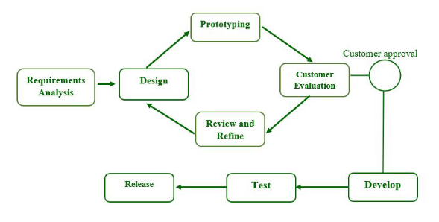

Figure 2.2 Prototype Methodology

**Step-1: Requirements gathering and analysis:**

Requirement analysis is the first step in developing a prototyping model. During this phase, the system’s desires are precisely defined. During the method, system users are interviewed to determine what they expect from the system.

**Step-2: Quick design:**

The second phase could consist of a preliminary design or a quick design. During this stage, the system’s basic design is formed. However, it is not a complete design. It provides the user with a quick overview of the system. The rapid design aids in the development of the prototype.

**Step-3: Build a Prototype:**

During this stage, an actual prototype is intended to support the knowledge gained from quick design. It is a small low-level working model of the desired system.

**Step-4: Initial user evaluation:**

The proposed system is presented to the client for preliminary testing at this stage. It is beneficial to investigate the performance model’s strengths and weaknesses. Customer feedback and suggestions are gathered and forwarded to the developer.

**Step-5: Refining prototype:**

If the user is dissatisfied with the current model, you may want to improve the type that responds to user feedback and suggestions. When the user is satisfied with the upgraded model, a final system based on the approved final type is created.

**Step-6: Implement Product and Maintain:**

The final system was fully tested and distributed to production after it was developed to support the original version. To reduce downtime and prevent major failures, the programmer is run on a regular basis.

## Requirement Gathering Techniques

* Questionnaire

## A questionnaire was distributed to gather detailed responses from potential users about their needs and preferences for this system. This method allowed for collecting structured data from a larger audience.

* Survey

## Surveys were used to quickly gather feedback from a students and lecturers. This helped in identifying the most desired features for the system.

## Tools and Technology

The development of the **EduConsult** utilized a variety of tools and technologies to ensure a smooth and efficient process. Below is an overview of the key tools and technologies used.

### Programming Language

Programming language is a computer language programmer use to develop system. Below section will discussed on the programming language used in developing this project.

#### PHP

PHP (Hypertext Preprocessor) is a programming language used mainly for building websites. It runs on the server, which means it can create web pages that change based on user input or data from a database. PHP is easy to use and works well with databases like MySQL, making it popular for developing dynamic websites and web applications.

### Database

A database is an organized collection of data that can be easily accessed and managed. It stores information in tables with rows and columns, allowing users to retrieve and manipulate data using a query language like SQL. Databases are commonly used in applications and websites to store information like user accounts and product details.

### HTML/CSS

HTML (Hypertext Markup Language) is the standard language used to create and design web pages. It uses tags to structure content, such as headings, paragraphs, links, images, and lists. HTML tells the web browser how to display the content on a webpage. It’s the foundation of any website, providing the basic layout and structure that can be styled with CSS and made interactive with JavaScript.

### MySql

MySQL is a popular open-source relational database management system (RDBMS) that uses SQL (Structured Query Language) to manage and manipulate data. It allows users to create, read, update, and delete data in structured tables. MySQL is widely used for web applications due to its speed, reliability, and ease of use. It supports large databases and multiple users, making it a common choice for websites, applications, and data-driven projects.

### Web Development Tools

Web development tools are software applications that help developers create and maintain websites. In the development of the "Interactive Incident Reporting System," several tools were utilized to enhance productivity and streamline the development process.

#### Visual Studio Code

Visual Studio Code (VS Code) is a lightweight, open-source code editor developed by Microsoft. It supports multiple programming languages and offers features like syntax highlighting, intelligent code completion (IntelliSense), debugging tools, and an integrated terminal. With a wide range of extensions, users can customize their development environment, making it a popular choice among developers for web and software development.

#### Xampp

XAMPP is a free and open-source cross-platform web server solution that includes Apache, MySQL, and PHP. It was used to create a local server environment for developing and testing the application. XAMPP made it easy to set up the necessary components for running the incident reporting system on a personal computer.

# SYSTEM DESIGN

## System Design

The purpose of this chapter is to document the system specifications. The system design is divided into two parts which are interface design and database design.

## Student Flowchart

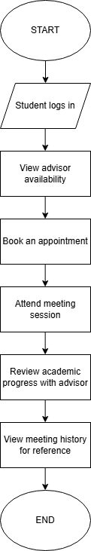

### Advisor Flowchart

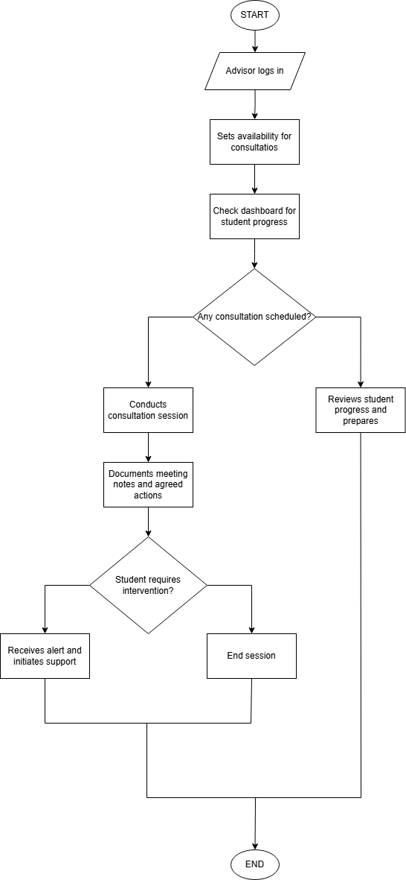

### Admin Flowchart

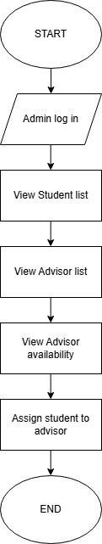

## Database Design

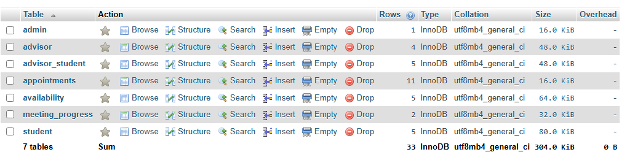

### Admin Table

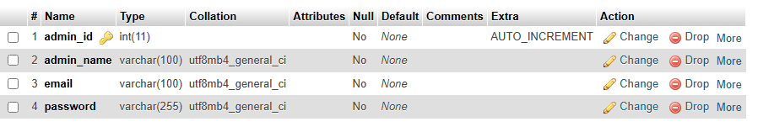

### Advisor Table

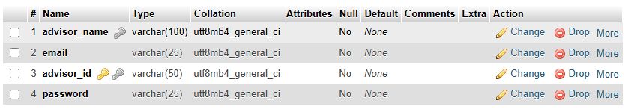

### Advisor_Student Table

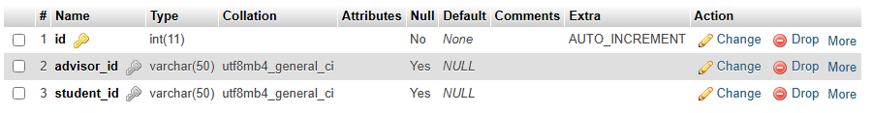

### Appointment Table

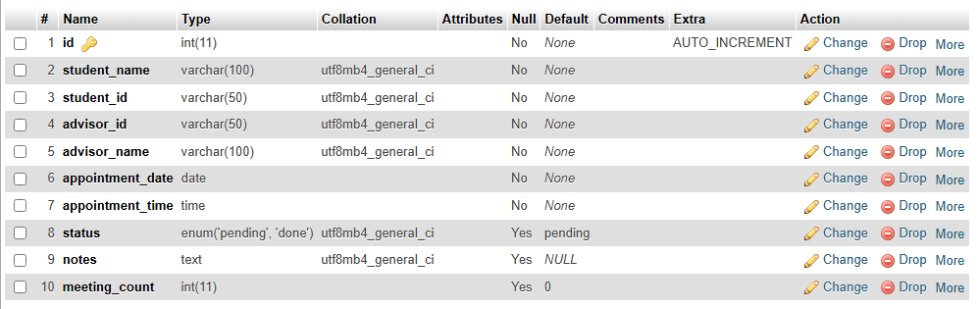

### Availability Table

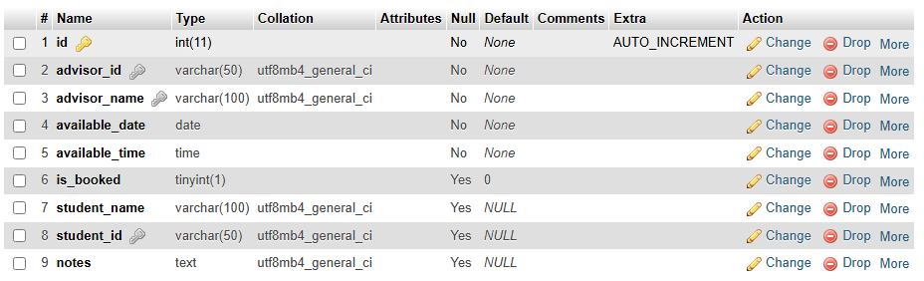

### Meeting_Progress Table

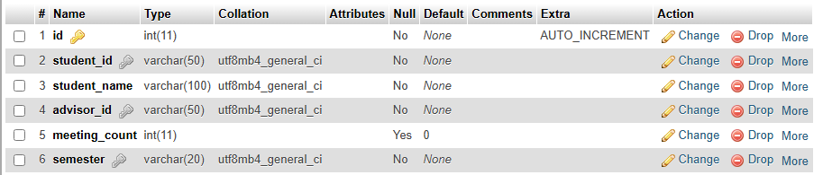

### Student Table

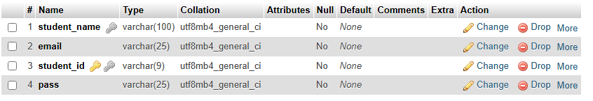

## Entity Relationship Diagram

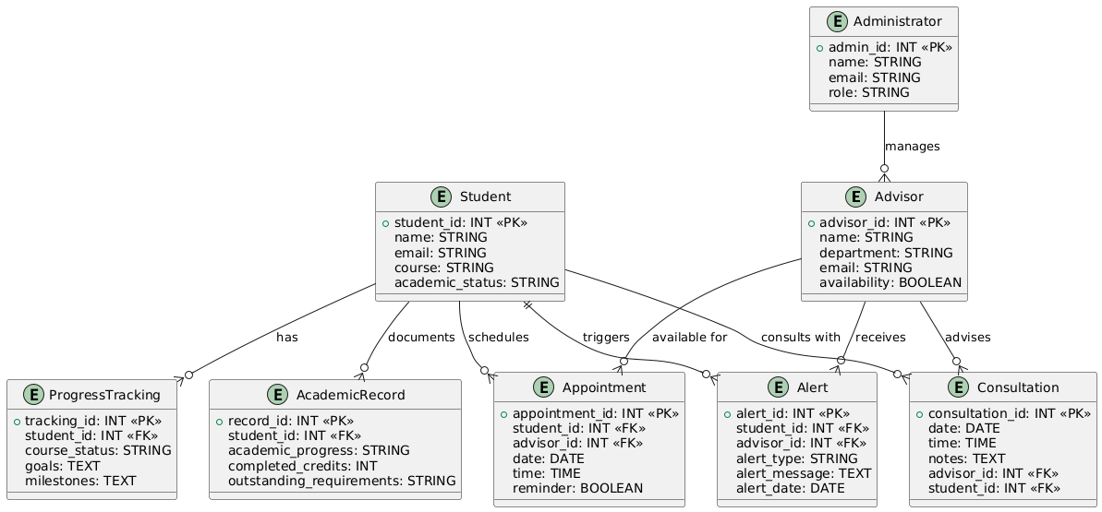

# implementation and testing

## Implementation and Testing

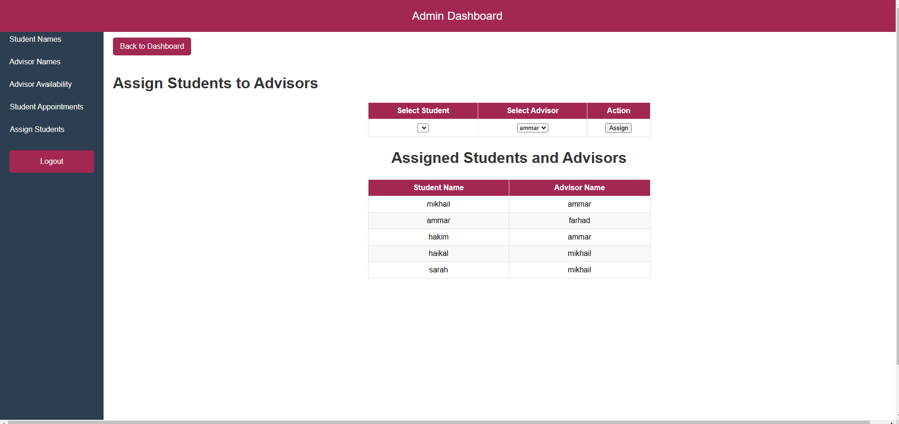 Admin can assign student to advisor and one student can only be assigned to one advisor but one advisor can have many students.

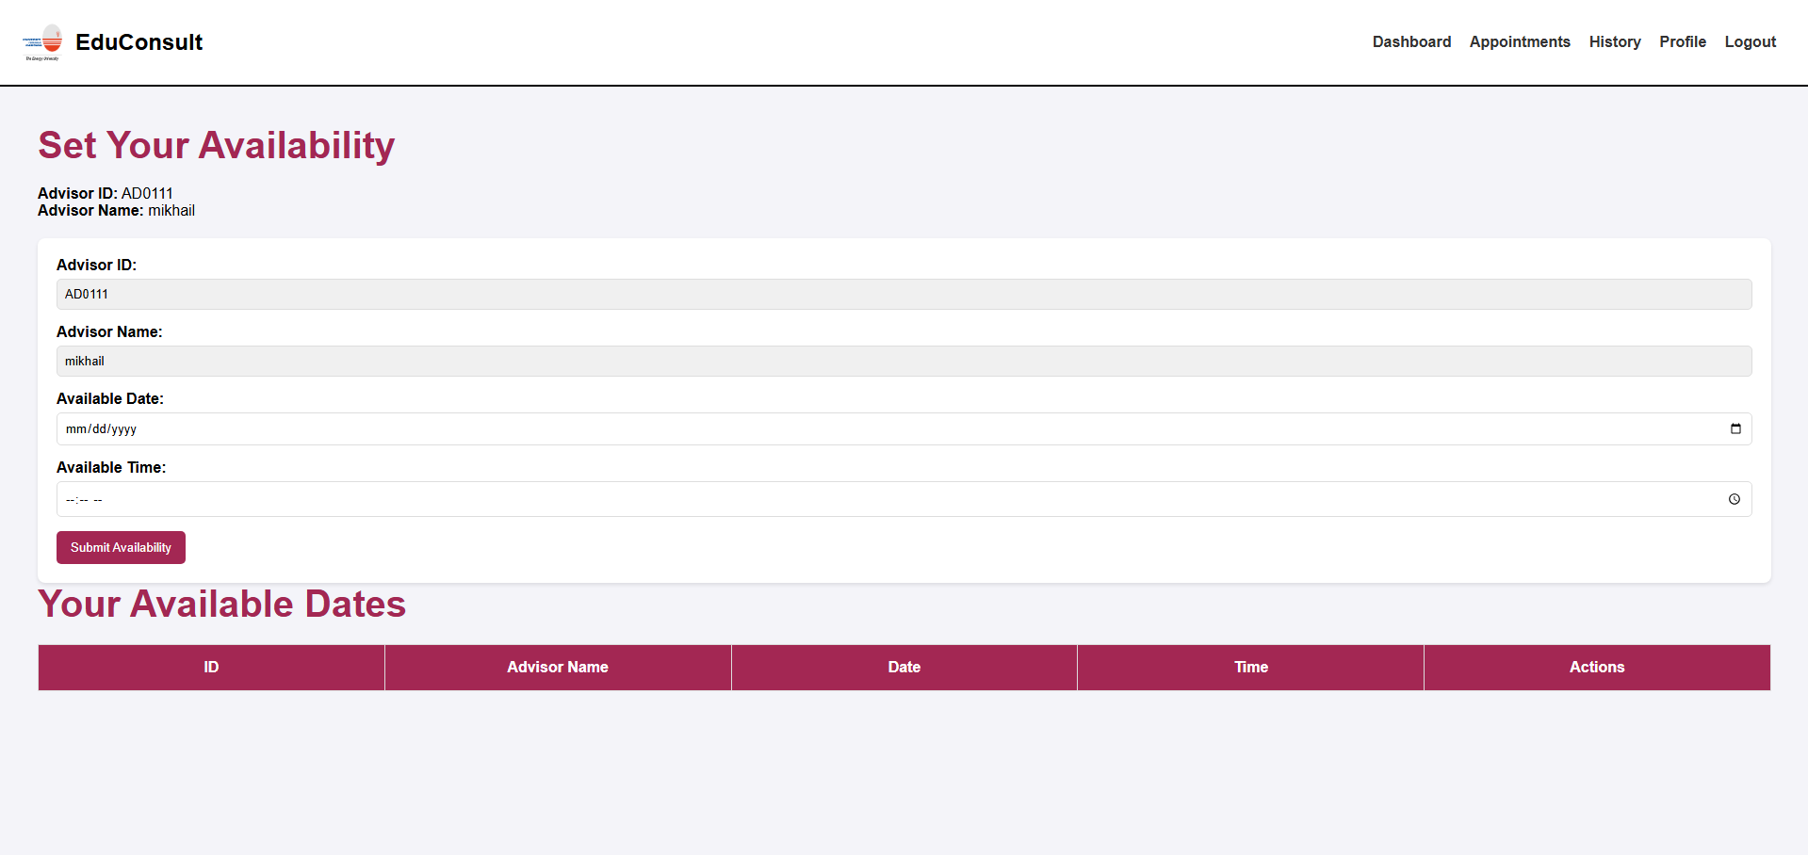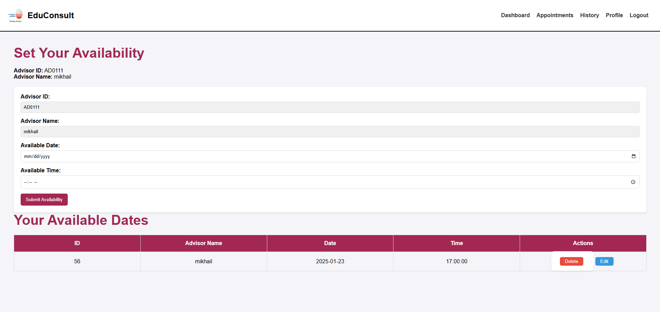 Advisor can set their date and time and if they have submitted the availability it will appear on the “Your Available Dates” table.

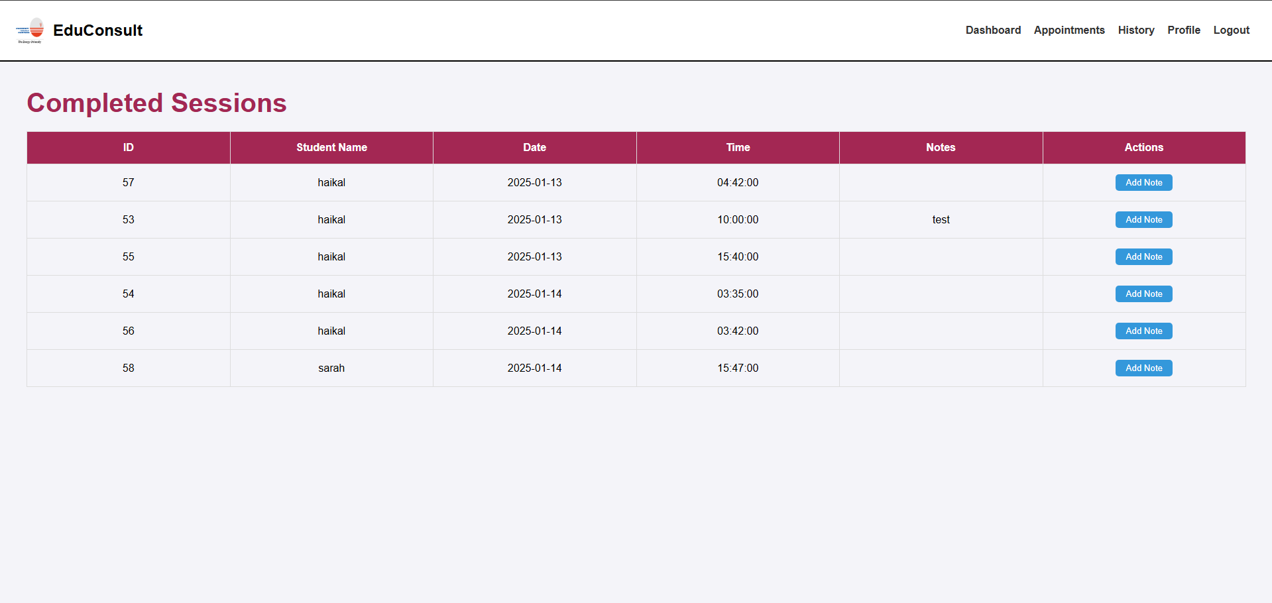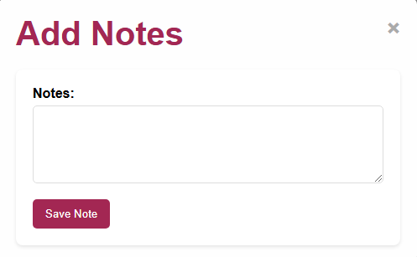 Advisor can view the completed session and can add note so the student can also view it.

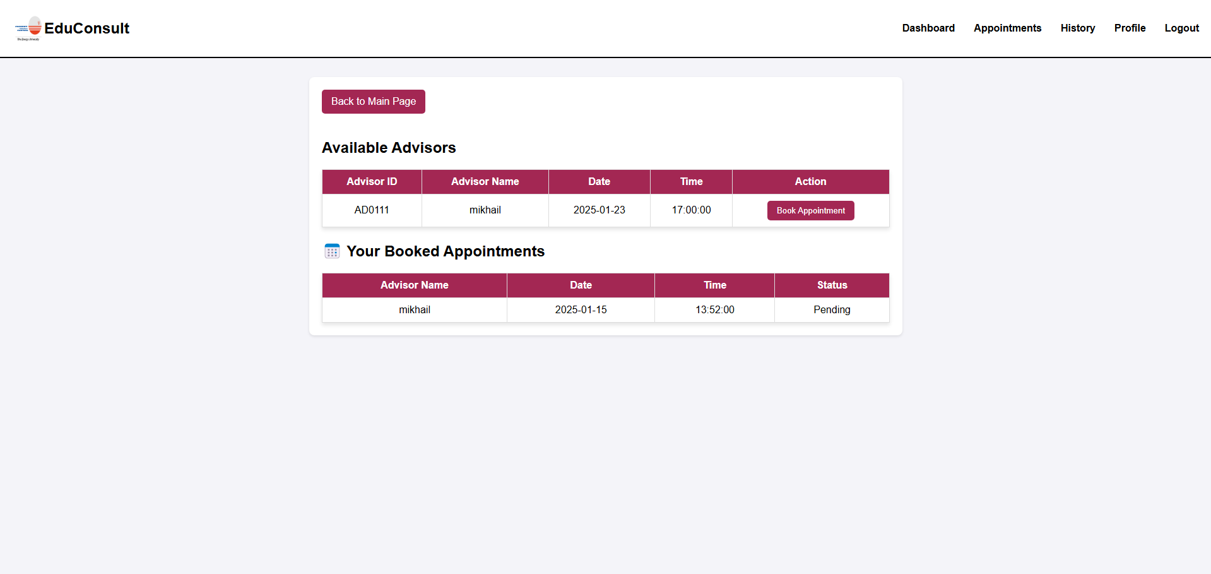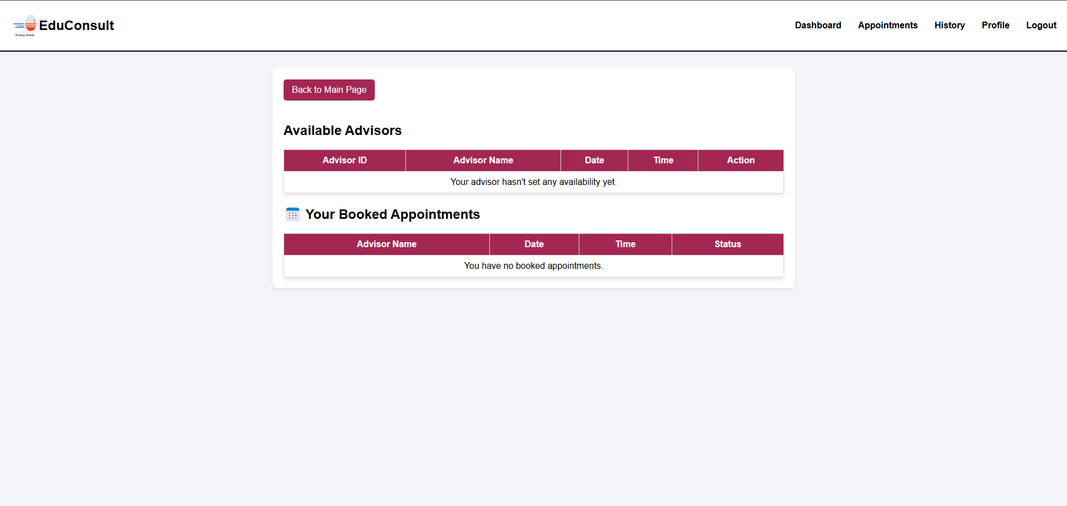 This page the student can view if their advisor has set an appointment for them to booked, if they have booked an appointment it will appear in the “Your Booked Appointments” table and if their advisor hasn’t set any availability it will appear “Your advisor hasn’t set any availability yet”.

## MySQL Connection using PHP Scripting / Adobe Setup

To set up the database connection for the EduConsult system, I used XAMPP, which includes Apache, MySQL, and PHP for local development. The database, created using phpMyAdmin, stores user credentials, appointments, and communication records. A PHP script (db_config.php) was written to establish a connection to the MySQL database using the mysqli extension, allowing the web application to interact with stored data. The connection parameters include the server’s name, username, password, and database name. This setup enables functionalities such as user authentication, appointment scheduling, and record management within the system. Tools like Visual Studio Code were used for coding, and HTML, CSS, and PHP were integrated to create a seamless experience.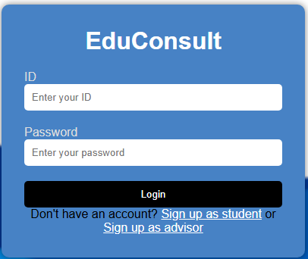

Figure 4.1 Login Page for EduConsult

## Interface Design

**Landing Page**

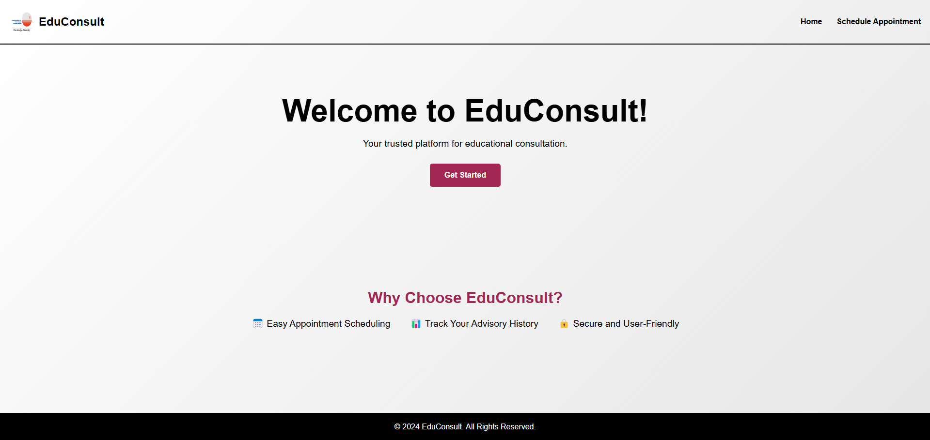This is the landing page for EduConsult if the user press “Get Started” it will redirect to login page.

**Login Page**

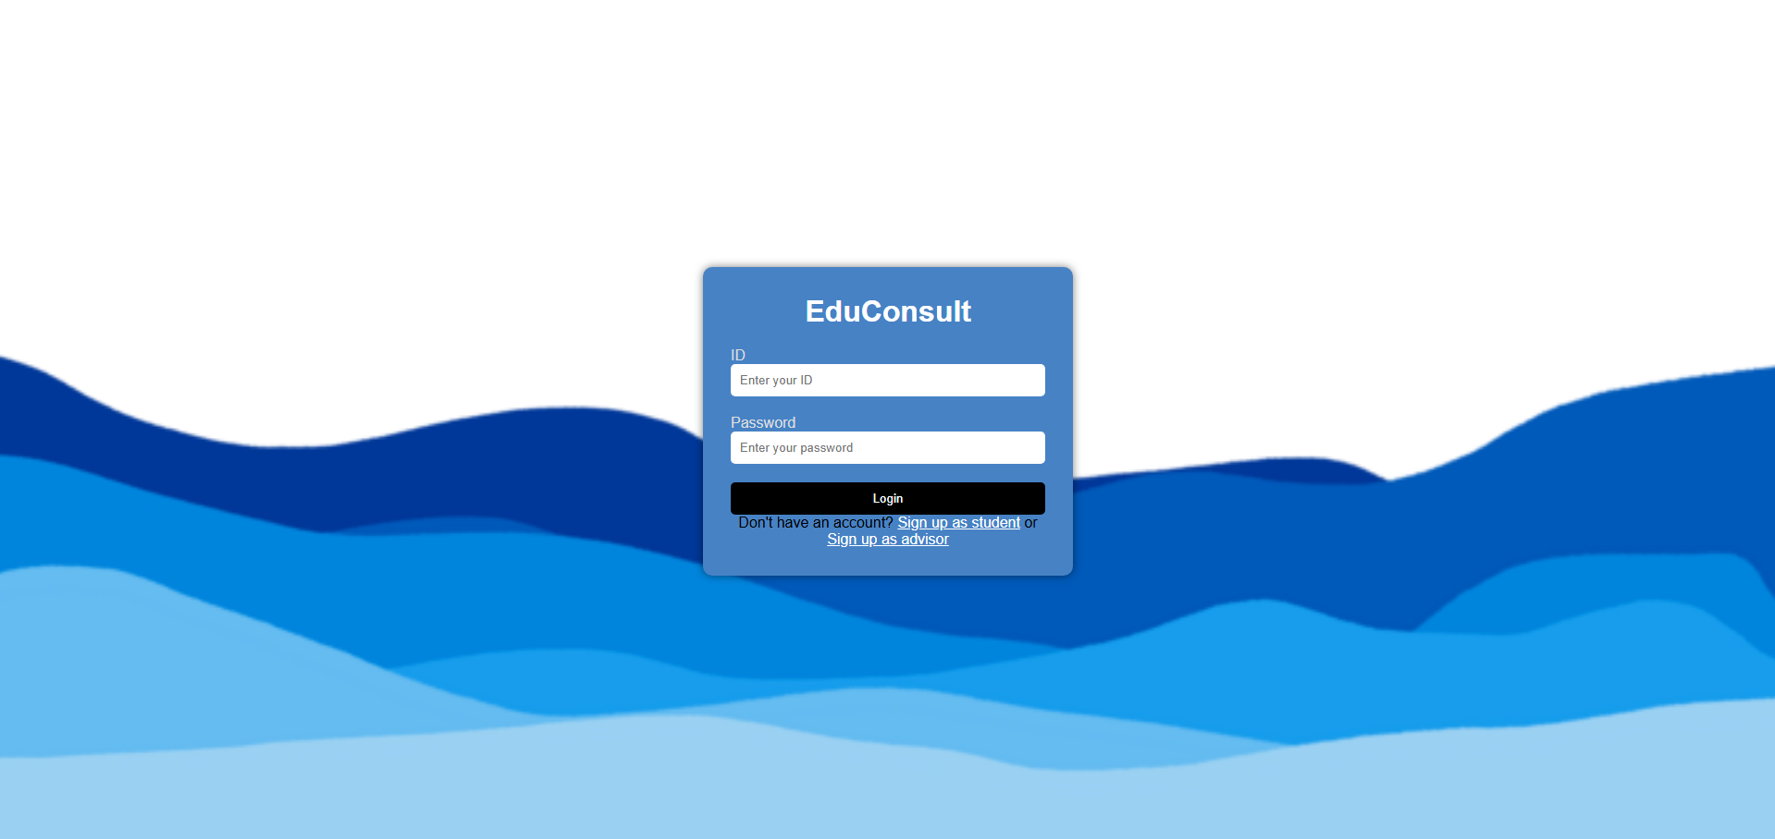

This is the login page where if they already have an account, they can login using their ID and Password. If they don’t have and account, they can sign up as student or sign up as advisor. After a student has login, it will redirect to student main page and if an advisor has login, it will redirect to advisor main page and the same with admin.

### Admin Interface

**Admin Main Page**

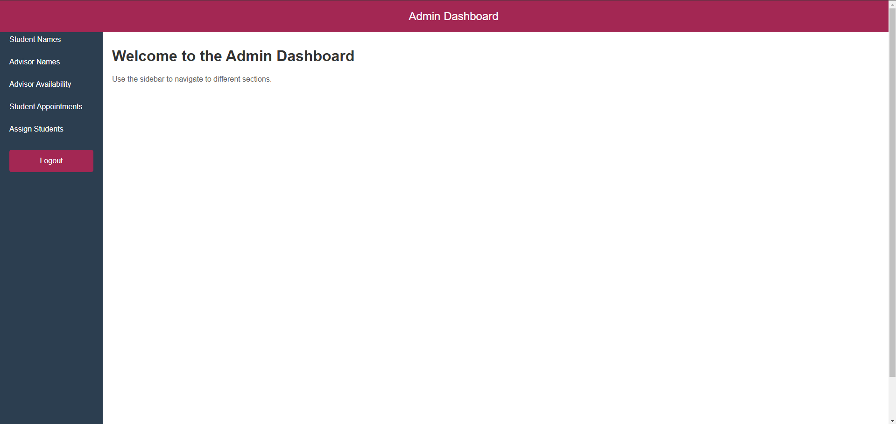

This is the admin main page. Admin can view student name, advisor name, advisor availability, student appointment and can assign student to advisor.

Student Name

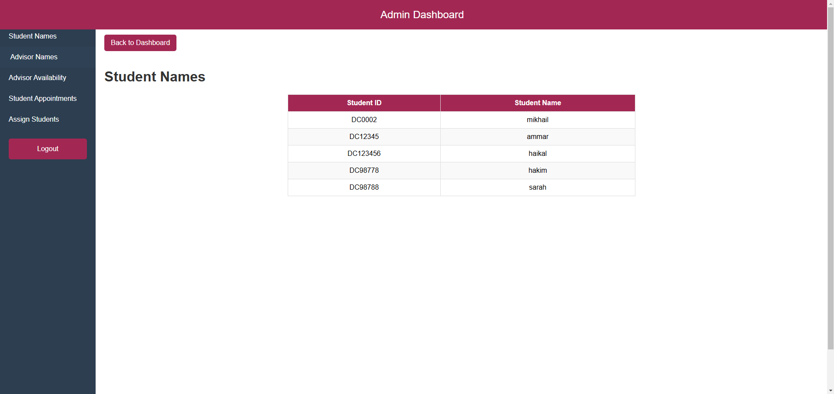

**Advisor Name**

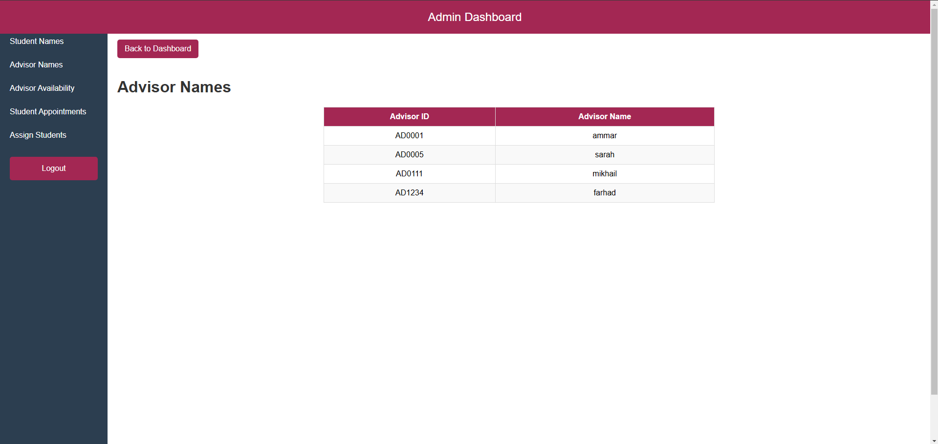

**Advisor Availability**

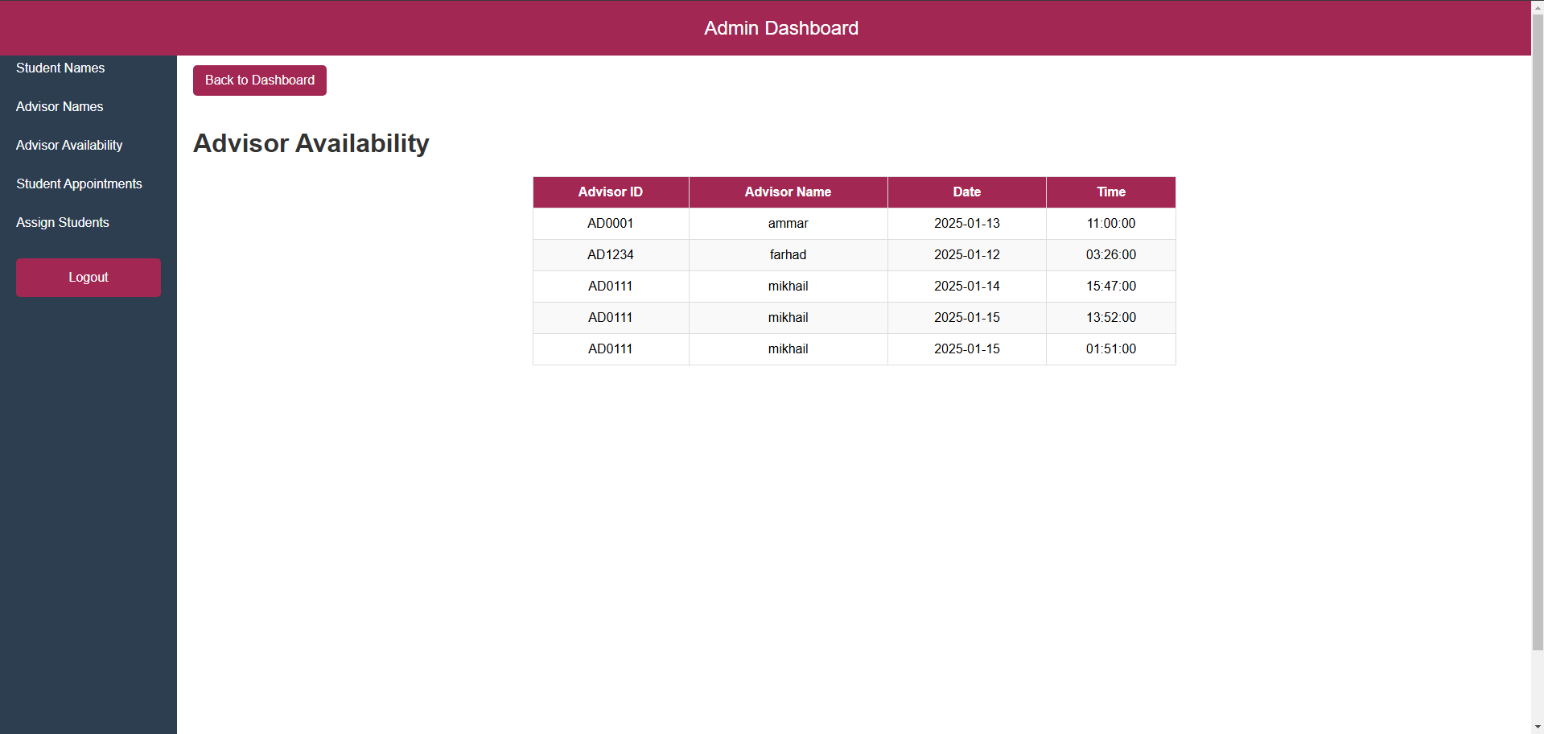

**Student Appointment**

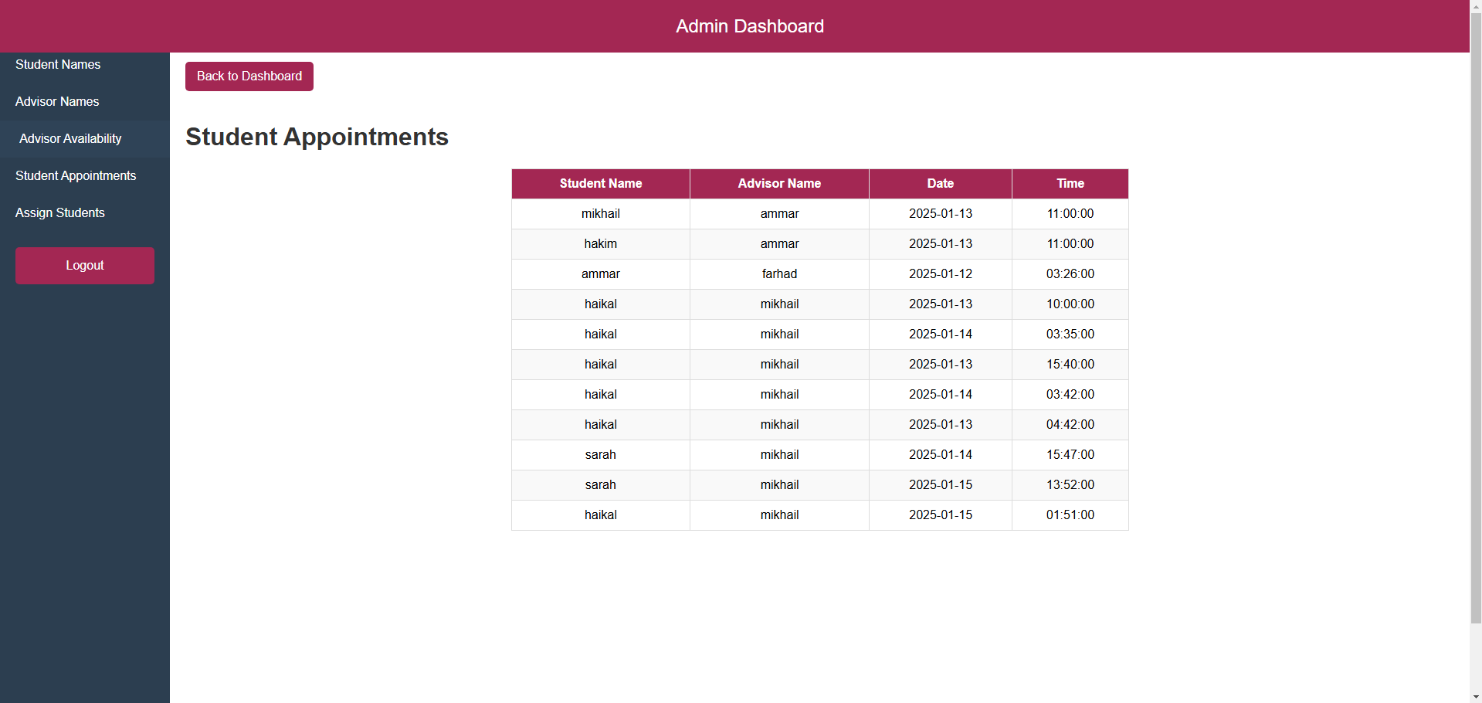

**Assign Student**

Admin can assign student to advisor and one student can only be assigned to one advisor but one advisor can have many students.

### Advisor Interface

**Advisor Main Page**

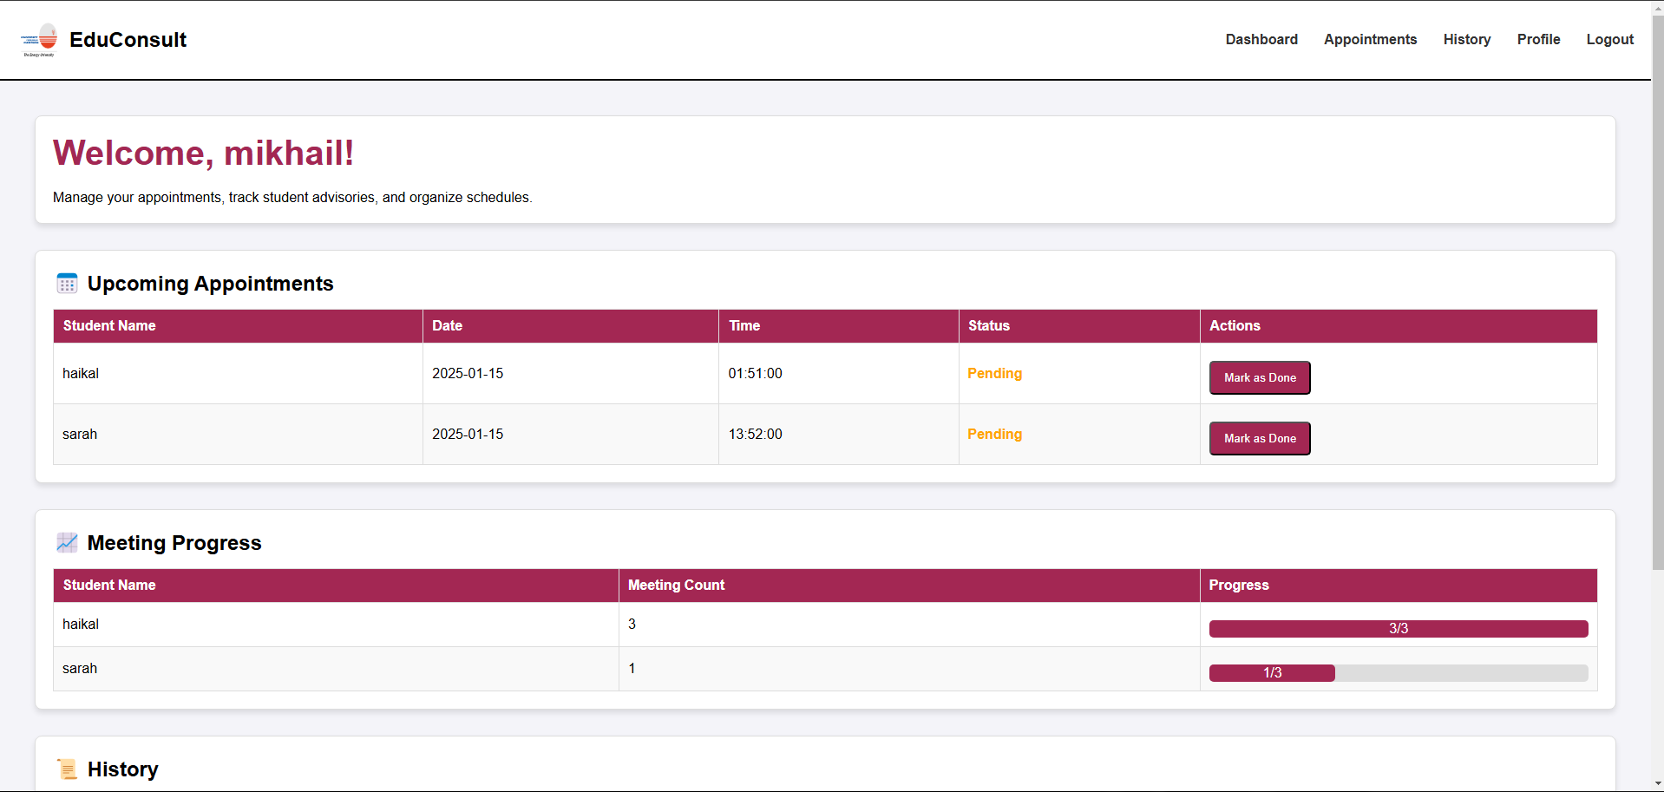 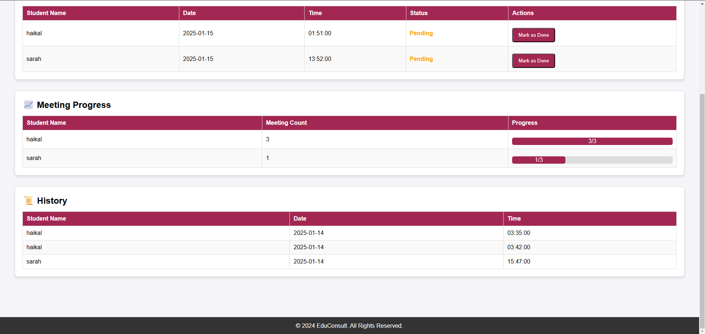This is the advisor main page where advisor can view their upcoming appointment, meeting progress and history. With the Appointment button they can set their availability. For history they can view the meeting history.

**Availability Page**

Advisor can set their date and time and if they have submit the availability it will appear on the “Your Available Dates” table.



**Advisor History Page**

Advisor can view the completed session and can add note so the student can also view it.



### Student Interface

**Student Main Page**

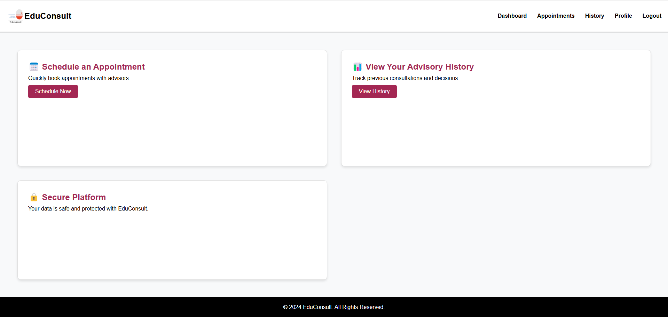This is the student main page where they can schedule an appointment and view history.

**Appointment Page**

This page the student can view if their advisor has set an appointment for them to booked, if they have booked an appointment it will appear in the “Your Booked Appointments” table.

If their assigned advisor hasn’t set any availability yet it will appear as “Your advisor hasn’t set any availability yet”.

**Student History Page**

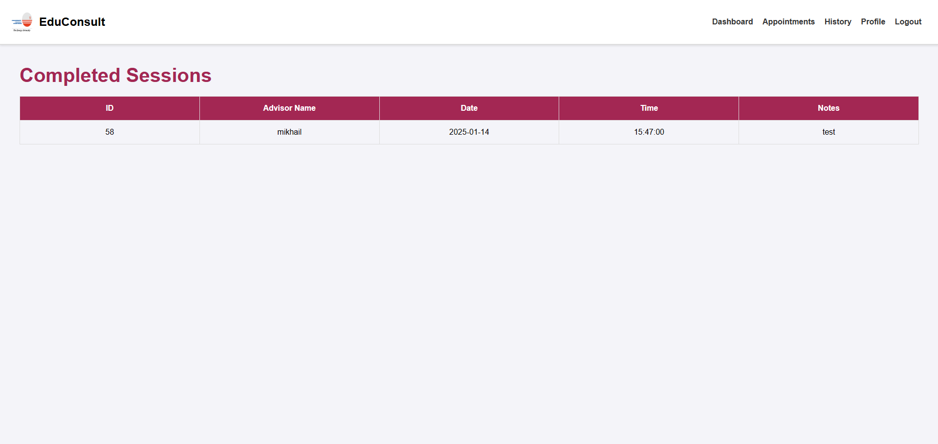This is the student history page where they can view their completed session and can view what the advisor had written in the note section.

# CONCULSION AND DISCUSSION

## Conclusion

## In conclusion, the EduConsult system revolutionizes academic advising by streamlining the process, reducing administrative burdens, and fostering effective communication between advisors and students. By offering features such as advisor availability management, progress tracking, and secure record-keeping, the system enhances the overall advising experience. With improved efficiency and accessibility, EduConsult empowers students to receive timely support and guidance, ultimately contributing to their academic success and personal growth.

## Discussion

* **Problem 1:** One problem I encountered was difficulty establishing a connection between the application and the database. This was caused by incorrect configuration settings, issues with server access, or MySQL permission problems, which prevented the system from fetching or storing data correctly.
* **Problem 2:** Another challenge I faced was managing appointment scheduling. I encountered issues with overlapping appointment slots, which caused confusion for both advisors and students. Ensuring that the scheduling system was accurately tracking availability and preventing double bookings took extra time to resolve.

## Future Works

For future improvement, the system could include implementing a notification feature to alert students and advisors about upcoming appointments, cancellations, or changes. A robust communication system will be introduced to facilitate real-time messaging between advisors and students, enhancing collaboration. Additionally, after each meeting, students will receive a summary or score based on their session, helping them track their progress and receive valuable feedback.

REFERENCES

https://www.geeksforgeeks.org/software-prototyping-model-and-phases/

APPENDIX A: QUESTIONNAIRE/SURVEY/INTERVIEW

**Section A**

**Question 1:** Education Level.

Justification: To classify the current education level of each respondent.

**Question 2:** Do you stay on UNITEN campus?

Justification: To identify whether the respondent is an in- campus student or not.

**Question 3:** Are you a full-time or part-time student?

Justification: To identify if the student/advisor can have flexible time table.

**Question 4:** How often do you have a meeting with your advisor?

Justification: To identify the rate of frequency of users meeting with their advisor/advise.

**Question 5:** How often do you experience difficulties in scheduling appointments with your advisor?

Justification: To justify the probabilities of users faced with difficulties in scheduling appointments

**Section B**

**Question 6:** I find it convenient with the current advisor/advisee management system in UNITEN?

Justification: To identify users have satisfaction with the current system

**Question 7:** I find it hard to keep track of the status of my advising appointments for the current advisor-advisee process.

Justification: To identify whether users have any issues when using the current system.

**Question 8:** I hardly receive reminder for my advising session.

Justification: To justify whether users receive any notifications and updates from the current system.

**Question 9:** I hardly make appointments for my advising session with my advisor.

Justification: To identify the users’ satisfaction with the interface

**Question 10:** I hardly follow up my appointments for my advising session with my advisor.

Justification: To know the user’s perception on the current system

**Section C**

**Question 11:** I expect an online advisory system where I may easily make an appointment with my advisor.

Justification: To determine the rate of user-friendliness of proposed system.

**Question 12:** I expect to complete my advisory scheduling in a smooth and fast manner without any interruptions or confusion throughout the entire session.

Justification: To identify the user expectations toward proposed system.

**Question 13:** I expect to receive any notifications and updates related to the advising session in a timely manner via the system.

Justification: To justify the approval rate of users who wish to have a proposed system to receive any notifications and updates.

**Question 14:** I expect an attractive and modern interface for advisory system.

Justification: To classify user expectations toward an attractive interface and data synchronization.

**Question 15:** I expect to retrieve the history log of my advisory schedules via the system.

Justification: To ensure users will get a more user-friendly experience

APPENDIX B: ORIGINAL DATA

**Section A**

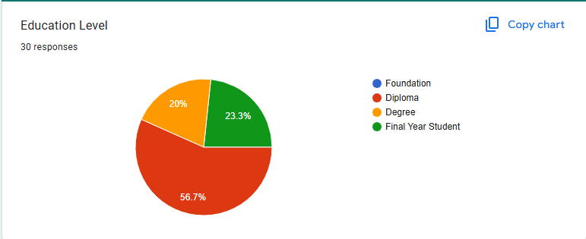 *Analysis:*

The analysis of 30 responses reveals that the majority (56.7%) of users are at the diploma level, highlighting a strong demand for resources like transfer guidance and career planning. Final-year students (23.3%) and degree-level users (20%) also represent significant groups, indicating the need for job placement support, postgraduate guidance, and advanced learning tools. The absence of responses from the foundation level suggests a gap in outreach or alignment with their needs, which may require targeted strategies. Overall, the EduConsult System should prioritize diploma-level services while ensuring robust features for final-year and degree users to address their academic and career transitions effectively.

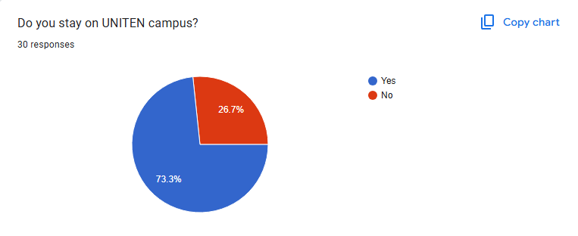 Analysis: The responses show that a majority (73.3%) of users stay on the UNITEN campus, indicating that most users likely have easy access to on-campus resources and events. This group may prioritize services such as in-person consultations, campus-specific information, and academic support. On the other hand, the 26.7% who live off-campus may need more flexible, remote-access options to ensure they can benefit from the EduConsult System despite their physical distance from campus. These insights suggest that the system should balance both on-campus and remote features to cater to the diverse needs of its user base.

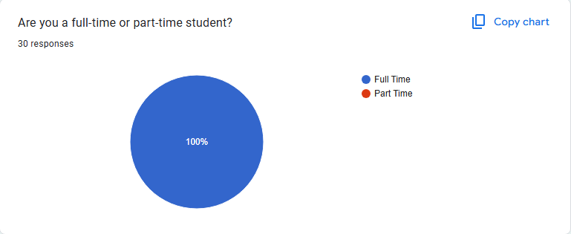 Analysis: The responses show that 100% of users are full-time students, with no part-time students in the sample. This suggests that the EduConsult System should focus on providing resources and services that cater to full-time students' needs, such as extensive academic support, career guidance, and extracurricular opportunities. Given the absence of part-time students, the system may not need to prioritize flexible or time-efficient features, but should instead focus on offering comprehensive, in-depth services that align with the schedules and commitments of full-time students.

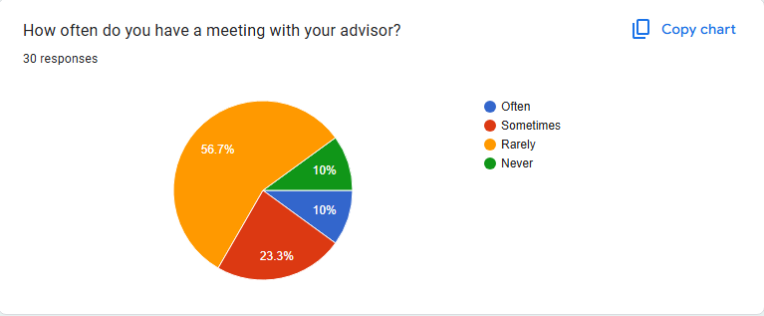 Analysis: The responses show that the majority of students (56.7%) meet with their advisor rarely, followed by 23.3% who meet sometimes, and 10% who meet often or never. This indicates that most students may not have frequent, consistent advisor interactions and could benefit from additional support through the EduConsult System, such as self-guided resources or tools for academic planning. For the smaller group that meets more often, the system can offer advanced features to complement regular advisor meetings. Tailoring the system to provide both independent and advisor-supported options will address the diverse needs of students based on their meeting frequency.

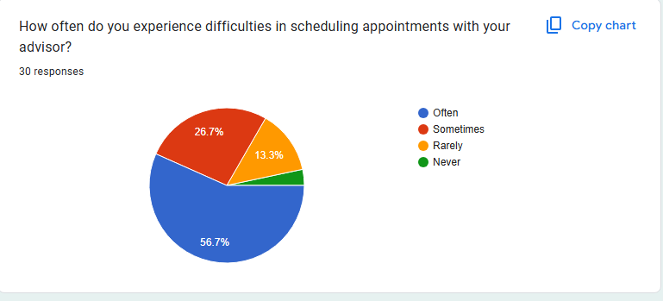 Analysis: The responses indicate that a significant portion of students (56.7%) often experience difficulties in scheduling appointments with their advisor, while 26.7% face this issue sometimes. Only a small percentage (13.3%) rarely encounter problems, and just 3.3% never face any scheduling challenges. This suggests that a majority of students struggle with accessing their advisors in a timely manner.

**Section B**

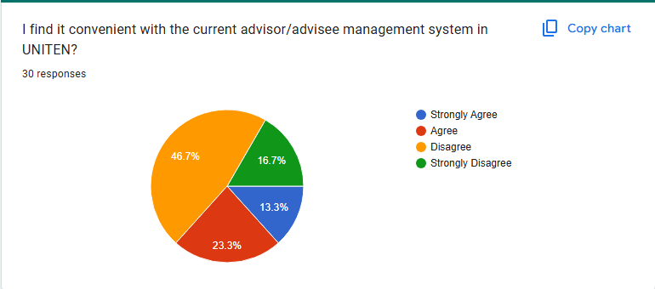 Analysis: The responses show that a significant portion of students (46.7%) disagree with the convenience of the current advisor/advisee management system, while 16.7% strongly disagree. Only 23.3% agree and 13.3% strongly agree, indicating a general dissatisfaction with the existing system. This suggests that many students find the current system inefficient or challenging to use, pointing to a clear opportunity for the EduConsult System to offer improvements, such as a more intuitive interface, better accessibility, and enhanced communication features to better meet students' needs.

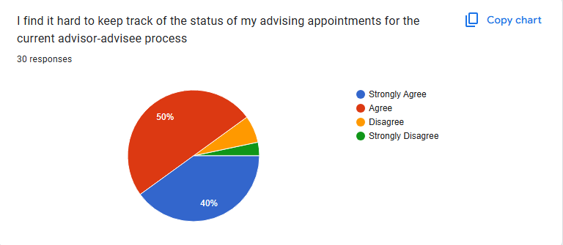

Analysis: The responses show that a large majority of students (90%) agree (50%) or strongly agree (40%) that it is hard to keep track of the status of their advising appointments. This indicates that the current system lacks effective tools for appointment management, leading to significant challenges in tracking and staying updated. With only a small portion (10%) disagreeing or strongly disagreeing, it is clear that there is a strong need for the EduConsult System to incorporate features like real-time status tracking, automated reminders, and a centralized view of appointment details to improve the user experience and streamline the advising process.

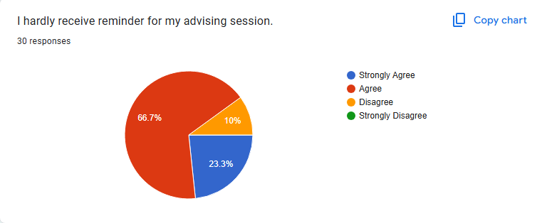 Analysis: The responses show that a majority of students (66.7%) agree and 23.3% strongly agree that they hardly receive reminders for their advising sessions. This highlights a significant gap in the current system's ability to notify students about their appointments. With only 10% disagreeing and no respondents strongly disagreeing, it is clear that reminders are a critical need. This feedback suggests that the EduConsult System should prioritize incorporating automated reminder features to help students stay informed and ensure they do not miss important advising sessions.

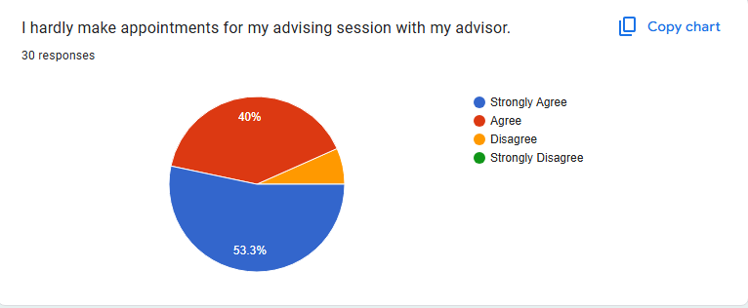 Analysis: The responses show that a significant majority of students (53.3%) strongly agree and 40% agree that they hardly make appointments for their advising sessions, indicating a clear challenge in scheduling or a lack of engagement with the advising process. With only 6.7% disagreeing and no students strongly disagreeing, it suggests that many students find it difficult or inconvenient to book appointments. This feedback highlights the need for the EduConsult System to implement an easier, more accessible appointment scheduling process, perhaps with flexible options and reminders, to encourage more regular advising sessions and enhance student engagement.

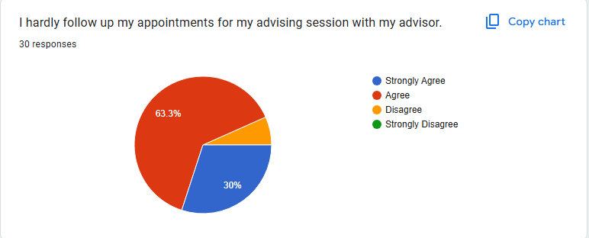 Analysis: The responses show that a large majority of students (63.3%) agree and 30% strongly agree that they hardly follow up on their advising appointments, suggesting that many students do not actively engage with their advisors after sessions. With only 6.7% disagreeing and no respondents strongly disagreeing, it indicates a significant gap in post-session follow-up. This highlights the need for the EduConsult System to include features such as automated follow-up reminders, action items, or a tracking system for students to monitor their progress, encouraging them to take necessary steps after their advising sessions and enhancing the overall effectiveness of the advising process.

**Section C**

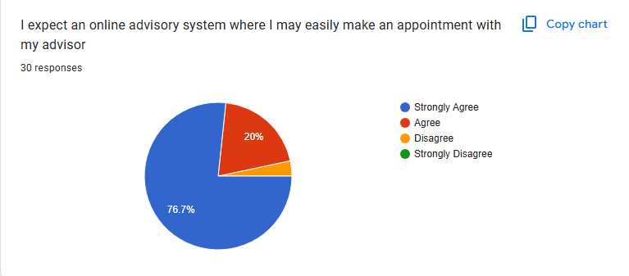 Analysis: The responses show that a significant majority of students (76.7%) strongly agree and 20% agree that they expect an easy-to-use online advisory system for scheduling appointments. This indicates a strong preference for digital solutions that offer convenience and accessibility. With only 3.3% disagreeing and no respondents strongly disagreeing, it is clear that the majority of students want a simplified, online appointment booking process. This feedback emphasizes the need for the EduConsult System to prioritize the development of a user-friendly, online scheduling feature to meet students' expectations and improve their overall academic advising experience.

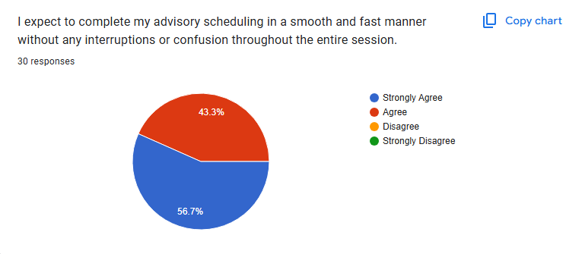 Analysis: The responses show that a significant majority of students (56.7%) strongly agree and 43.3% agree that they expect to complete their advisory scheduling smoothly and quickly without any interruptions or confusion. This indicates a strong preference for a seamless and efficient scheduling process. With no respondents disagreeing or strongly disagreeing, it is clear that students prioritize convenience and reliability in the system. This feedback underscores the importance of developing an intuitive, error-free scheduling interface in the EduConsult System to meet these expectations and enhance the overall user experience.

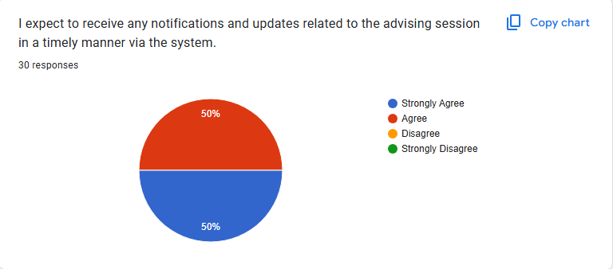 Analysis: The responses show that half of the students (50%) strongly agree and 50% agree that they expect to receive timely notifications and updates about their advising sessions. This indicates a strong consensus among students for the need to stay informed about their appointments and any related changes. With no students disagreeing or strongly disagreeing, it is clear that real-time communication is a key expectation. This feedback highlights the importance of incorporating automated, timely notifications in the EduConsult System to ensure students are always updated and can manage their advising sessions efficiently.

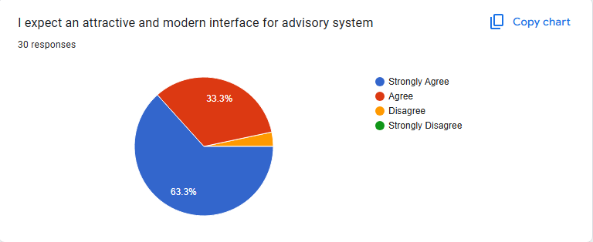 Analysis: The responses show that a majority of students (63.3%) strongly agree and 33.3% agree that they expect an attractive and modern interface for the advisory system. This indicates a strong preference for a visually appealing and user-friendly design. With only 3.3% disagreeing and no students strongly disagreeing, it is clear that students value a modern and intuitive interface. This feedback emphasizes the importance of prioritizing design in the EduConsult System, ensuring that it is both visually appealing and easy to navigate, thereby enhancing user engagement and satisfaction.

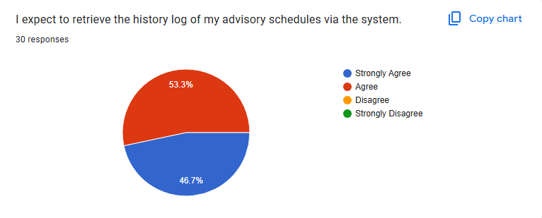 Analysis: The responses show that a significant majority of students (53.3%) agree and 46.7% strongly agree that they expect to retrieve the history log of their advisory schedules via the system. This indicates that almost all students value the ability to access a record of their past appointments, which would help them track their academic progress and review prior advice. With no students disagreeing or strongly disagreeing, it is clear that the history log feature is highly desired. This feedback highlights the importance of incorporating this functionality into the EduConsult System to meet students' needs for easy access to their advisory history and enhance their overall experience.

APPENDIX C: RESULT TABLE

|  |  |  |  |  |
| --- | --- | --- | --- | --- |
| Test Case | Expected Result | Actual Result | Status | Remarks |
| Admin assigns student to advisor | Student is successfully assigned to the selected advisor | Student assigned correctly | Pass | Working as expected |
| Advisor sets availability | Availability is saved and visible to students | Availability saved correctly | Pass | No issues found |
| Student books advisor's availability | Appointment is booked and confirmed | Appointment confirmed successfully | Pass | Working as expected |
| Advisor adds note to completed session | Notes are saved and accessible for future reference | Notes saved correctly | Pass | No issues found |
| Overlapping booking prevention | System prevents double booking for the same slot | Double booking prevented | Pass | Working as expected |